Results of Neighbourhood Plan initial consultation

Responses from 72 people at the two information events held 21 & 25 April.

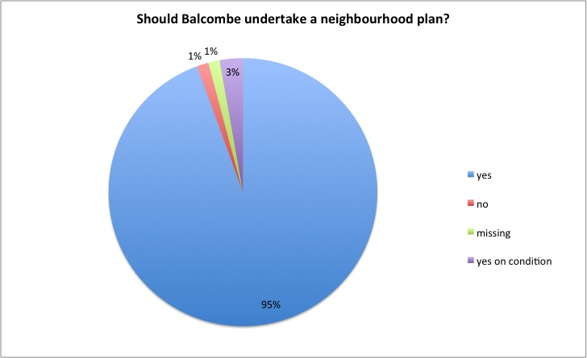

Responses to ‘Do you have any further comments?’

Comment | Freq
ensure everyone is consulted/ query re consultation/ want questionnaire | 5
thank you for putting on the event | 2
Only go for minimum development possible | 2
water sustainability | 2
extend burial space at the church | 1
preserve rural character | 1
housing should be close to centre | 1
safe/ better pedestrian access | 1
more parking | 1
infrastructure | 1
road traffic strain therefore no building | 1
remember 2005 campaign | 1
putting together plan is a big task | 1
‘not at any price' | 1
Balcombe is beautiful | 1
appoint a consultant to work on the plan | 1
no additional housing needed | 1
protect woods at vintons nurseries | 1
volunteering to help | 1
need to know who author is | 1
timing of CIL | 1
how to query spend of CIL | 1
good to get involved | 1
care needed re developers | 1
work with near villages | 1
no development outside the village | 1

What would you like to see included in the neighbourhood plan?

Comment | Freq
infrastructure general/ infrastructure insufficient | 8
housing for retirees/ sheltered housing | 7
Transport/ rail links | 7
parking/ speed restrictions | 6
affordable/ social housing | 6
new classroom/ school places | 5
mixed/ balanced development (residential & commercial) | 4
support for shops/ encouragement for retail | 3
housing for couples downsizing | 2
well planned houses ok/ need to fit with village | 2
no development outside built up area/ near cricket pitch | 2
access at station | 1
further meetings/ consultations | 1
housing for singles | 1
safe pedestrian/ cycling routes | 1
environment sustainability | 1
uncertain about shape of neighbourhood plan | 1
wealden style housing | 1
housing general | 1
housing smaller | 1
want consultation | 1
broadband | 1
appoint consultant/ external advice | 1
develop area by scout hut | 1
clear boundaries | 1
clarity on change of use | 1
concern re utility capacity | 1
as few homes as possible | 1
dedicated youth centre | 1
only build in infill | 1
South East is over populated | 1
option to object to development | 1
make use of brown sites | 1
use Glebe space for development | 1

